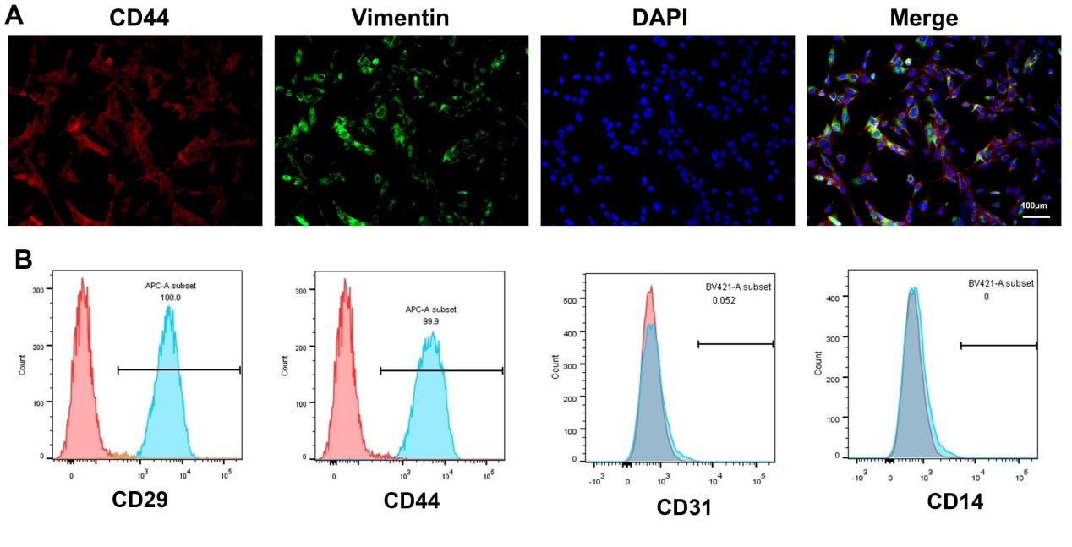
Supplementary Fig. 1. Identification of marker proteins of periodontal stem cells. A. The expressions of CD44 and vimentin were validated using the IF assay. Scale bar = 100 μm. B. The expressions of CD29, CD44, CD31, and CD14 were validated using flow cytometry.

Supplementary Table 1. The full names of the genes in the heat map.
Name in heat map | Full name
ACSL3 | acyl-CoA synthetase long-chain family member 3
SQLE | squalene epoxidase
MAPK1 | mitogen-activated protein kinase 1
NFE2L2 | NFE2 like bZIP transcription factor 2
PEBP1 | phosphatidylethanolamine binding protein 1
KEAP1 | kelch like ECH-associated protein 1
BECN1 | beclin 1
VDAC2 | voltage-dependent anion channel 2
HSBP1 | heat shock factor binding protein 1
IREB2 | iron-responsive element binding protein 2
EMC2 | ER membrane protein complex subunit 2
VDAC3 | voltage-dependent anion channel 3
HELLS | helicase, lymphoid-specific
PRNP | prion protein (Kanno blood group)
CD44 | CD44 molecule (IN blood group)
PRKAA1 | protein kinase AMP-activated catalytic subunit alpha 1
AKR1C1 | aldo-keto reductase family 1 member C1
AKR1C3 | aldo-keto reductase family 1 member C3
AKR1C2 | aldo-keto reductase family 1 member C2
NQO1 | NAD(P)H quinone dehydrogenase 1
ALOX15 | arachidonate 15-lipoxygenase
GSS | glutathione synthetase
PGD | phosphogluconate dehydrogenase
ACSF2 | acyl-CoA synthetase family member 2
MT1G | metallothionein 1G
G3BP1 | G3BP stress granule assembly factor 1
TP53 | tumor protein p53
TP63 | tumor protein p63
CFTR | CF transmembrane conductance regulator
CDKN1A | cyclin-dependent kinase inhibitor 1A
CRYAB | crystallin alpha B
PCBP2 | poly(rC) binding protein 2
FDFT1 | farnesyl-diphosphate farnesyltransferase 1
NCOA4 | nuclear receptor coactivator 4
CS | citrate synthase
RPL8 | ribosomal protein L8
GOT1 | glutamic-oxaloacetic transaminase 1
OTUB1 | OTU deubiquitinase, ubiquitin aldehyde binding 1
ATG7 | autophagy related 7
LPCAT3 | lysophosphatidylcholine acyltransferase 3
ELAVL1 | ELAV-like RNA binding protein 1
RB1 | RB transcriptional corepressor 1
G6PD | glucose-6-phosphate dehydrogenase
BAP1 | BRCA1-associated deubiquitinase 1
FADS2 | fatty acid desaturase 2
EPAS1 | endothelial PAS domain protein 1
PHKG2 | phosphorylase kinase catalytic subunit gamma 2
GPX4 | glutathione peroxidase 4
TFRC | transferrin receptor
SLC40A1 | solute carrier family 40 member 1
HMOX1 | heme oxygenase 1
MUC1 | mucin 1, cell surface associated
PRKAA2 | protein kinase AMP-activated catalytic subunit alpha 2
HSPB1 | heat shock protein family B (small) member 1
MAP1LC3A | microtubule-associated protein 1 light chain 3 alpha
MAP1LC3B | microtubule-associated protein 1 light chain 3 beta
CHAC1 | ChaC glutathione specific gamma-glutamylcyclotransferase 1
SLC1A5 | solute carrier family 1 member 5
CBS | cystathionine beta-synthase
FTL | ferritin light chain
ANO6 | anoctamin 6
SLC39A14 | solute carrier family 1 member 5
SLC3A2 | solute carrier family 3 member 2
MDM2 | MDM2 proto-oncogene
ACSL4 | acyl-CoA synthetase long-chain family member 4
DPP4 | dipeptidyl peptidase 4
ACO1 | aconitase 1
LAMP2 | lysosomal associated membrane protein 2
TF | transferrin
AURKA | aurora kinase A
SAT1 | spermidine/spermine N1-acetyltransferase 1
ATF4 | activating transcription factor 4
ATG5 | autophagy related 5
PTGS2 | prostaglandin-endoperoxide synthase 2
ZEB1 | zinc finger E-box binding homeobox 1
ACSL1 | acyl-CoA synthetase long-chain family member 1
ACACA | acetyl-CoA carboxylase alpha
CISD1 | CDGSH iron sulfur domain 1
ACSL6 | acyl-CoA synthetase long-chain family member 6
SLC39A8 | solute carrier family 39 member 8
FTH1 | ferritin heavy chain 1
MAP3K5 | mitogen-activated protein kinase kinase kinase 5
SLC11A2 | solute carrier family 11 member 2
ABCC1 | ATP binding cassette subfamily C member 1 (ABCC1 blood group)
HMGB1 | high mobility group box 1
GCLM | glutamate-cysteine ligase modifier subunit
ALOX15B | arachidonate 15-lipoxygenase type B
GCLC | glutamate-cysteine ligase catalytic subunit

